In sum, to hide your cmds, using a script but to view history, then your view-history cannot be hidden due to the nature you config it as ‘open’ to all kind… In fact, after your setting even the #comment-out cmd will be put into your history, interesting!

History from script is not useful as you thought because it will show off your history-sneak even all your command is invoked from the script

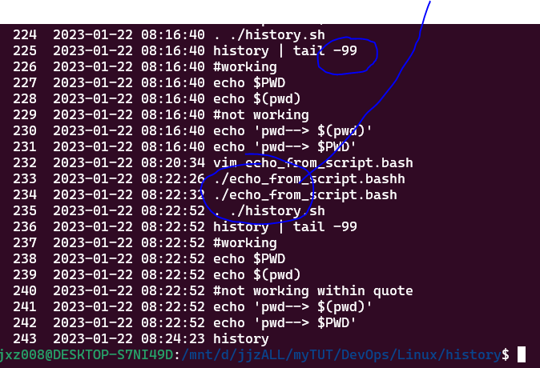

See – the real cmd from ./echo_from_script.bash has been hidden but not the from –

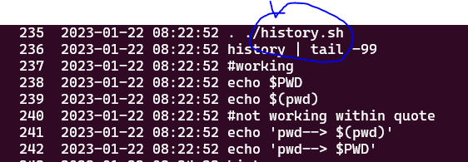

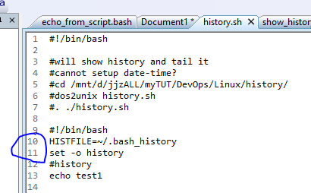

Ln10 and 11 are double-edged, after that cmd inside of the script will also be exposed!!